New Distributor Setup

**1. Purpose of the Document:**

This document contains information about how to set up the New Distributor in to MDS.

* If we received any new request from business user regarding new distributor setup, we will receive the file format which includes all the details about the Distributor as show in the below.

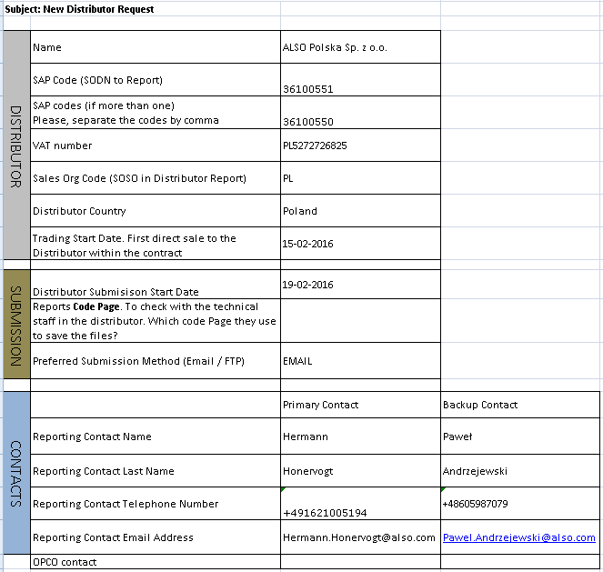

* The following link is the URL for MDS. The person should have the login access into this URL.

[Master Data Manager](http://gbem-ap138/MDS/)

* Once click the above link the below screen shot will be appeared to you, click on Explorer

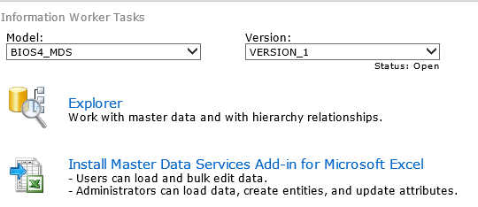

* The MDS application list the tabs which are existing as shown in the below. Place the cursor on Entities tab you will see the list of Entities.

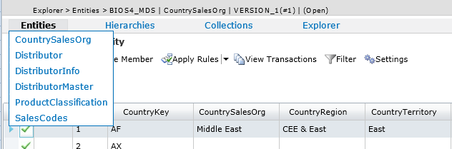

* Before going to set up the new Distributor into MDS, we should check the existence of the Distributor into **Distributor**, **DistributorInfo** and **DistributorMaster** whether the requested Distributor is already setup or not?
* Here is the example for checking distributor existence. We can apply the filters based on DistributorId to check. And we can check in the database level as well.

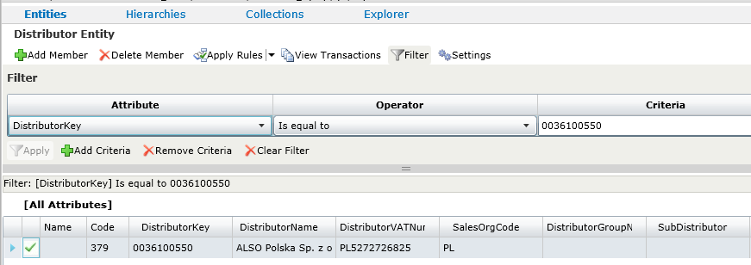

SELECT * FROM [BIOS4_MDS].[mdm].[VW_DistributorInfo] WHERE DistributorId like '%36100550%'

SELECT * FROM [BIOS4_MDS]. [mdm].[VW_Distributor] WHERE DistributorKey like '%36100550%'

SELECT * FROM [BIOS4_MDS]. [mdm].[VW_DistributorMaster] WHERE DistributorSAPKey like %36100550%'

* In the above New Distributor Request we can see the two SAP codes (**36100551 & 36100550**). We should do setup for both the SAP Codes.
* The following steps to complete the new distributor setup into MDS for one of the above SAP code (36100551)
* **Step1 :** Click on Entities 🡪 click on Distributorinfo 🡪 click on **Add Member**

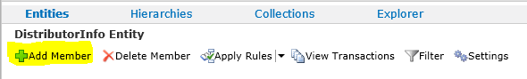

* **Step2:** The details window will open as shown below, should enter the details as per the sheet which is provided by the business user.
* **Step3 :** In this scenario as per the given file the fields will be like –

**Name :**

**Code : 803 (Auto Generated)**

**DistributorId : 36100551 (SAP Code)**

**DistributorContactId : 1 (Default)**

**ReportingFolder :**

**ReportingFile :**

**FileExtension :**

**ReportType : Sales/Stock**

**Version : 2014**

**FieldsListId : 11 (Default)**

**FileNaming :**

**CodePage : Windows -1252**

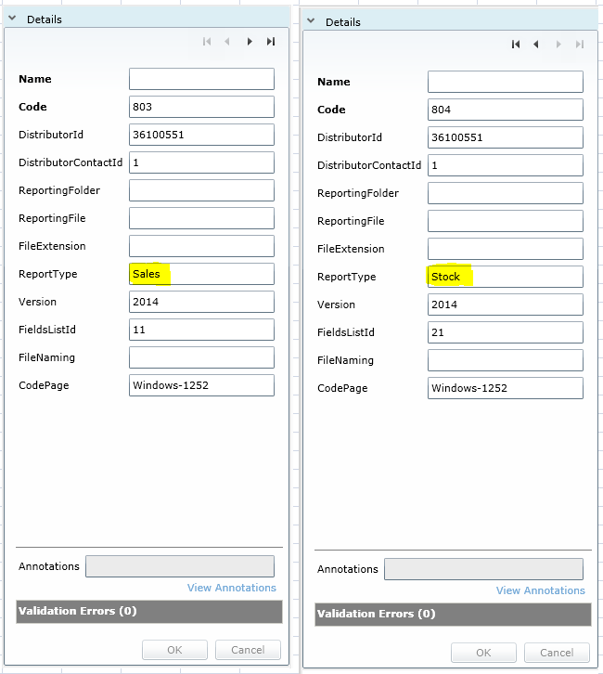

* **Step 4 :** Click ok the details will be saved into MDS
* **Step 5 :** Click on Add Member again and add the details as entered above for Stock also
* **Step 5 :** Check the same in Database level using the following query

SELECT * FROM [BIOS4_MDS].[mdm].[VW_DistributorInfo] WHERE DistributorId like '%36100550%'

* **Step 6 :** After adding the details into MDS the DistributorInfo table should appear the two records as shown below

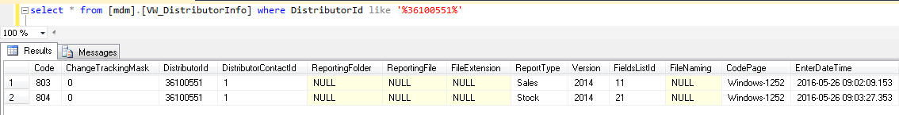

* **Step 7 :** Go to MDS application and click on Entities then Click on Distributor

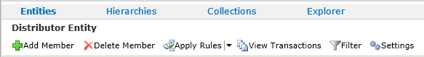

* **Step 8 :** Click on Add Member ,Details window will be populated as shown below and add the details as per the given sheet. The following fields are mandatory to add.

**Code : 376 (Auto Generated)**

**DistributorKey : 0036100551**

**DistributorName : ALSO Polska Sp. Z.o.o**

**DistributorVATNum : PL5272726825**

**SalesOrgCode : PL**

**DistributorCountry : PL**

**IsDistributor : 1**

**DistributorStartDate : 02/15/2016**

**DistributorEndDate : Should be Empty**

Here is the screen shot for all the fields:

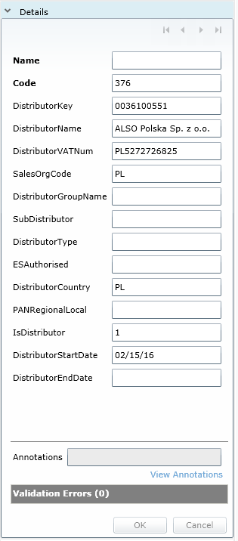

* **Step 9 :** Click Ok the details will be saved into MDS and verify the details which you are added using the following query.

SELECT * FROM [BIOS4_MDS]. [mdm].[VW_Distributor] WHERE DistributorKey like '%36100550%'

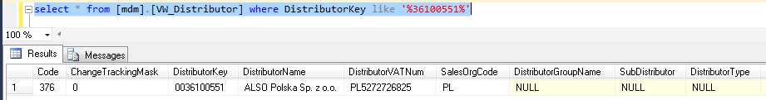

* **Step 10 :** Click on Entities 🡪 Click on DistributorMaster 🡪 Click Add Member

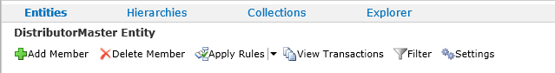

* **Step 11 :** Details window will be populated as shown below, Enter the details as per the given sheet. Contact details should be mandatory in this step. Click Ok, the details will be saved into MDS.

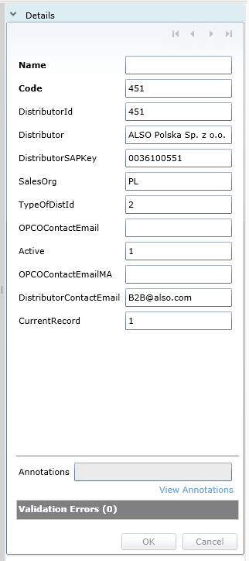

* **Step 12 :** Verify the details which you added in database level using the following query

SELECT * FROM [BIOS4_MDS]. [mdm].[VW_DistributorMaster] WHERE DistributorSAPKey like %36100550%'

**The Distributor set up is completed for one of the SAP Code – 36100551**